Verizon Fios G3100 Router Setup

John Grant

Step 1. Examine the back of your provided Verizon Fios router and write down the Admin URL and password (Note: Your password maybe different if you have changed it, if you do not remember the password you may need to reset it to default by pressing the reset button however, this will return it to default settings and you will need to reconfigure any settings you configured previously).

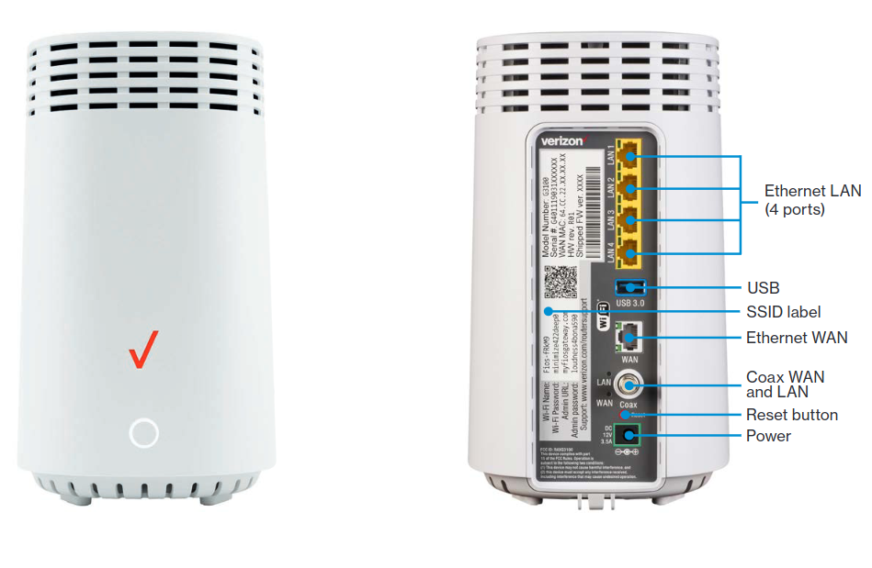

Step 2. Open a web browser on a device that is connected to the Verizon Fios router and enter the Admin URL and password.

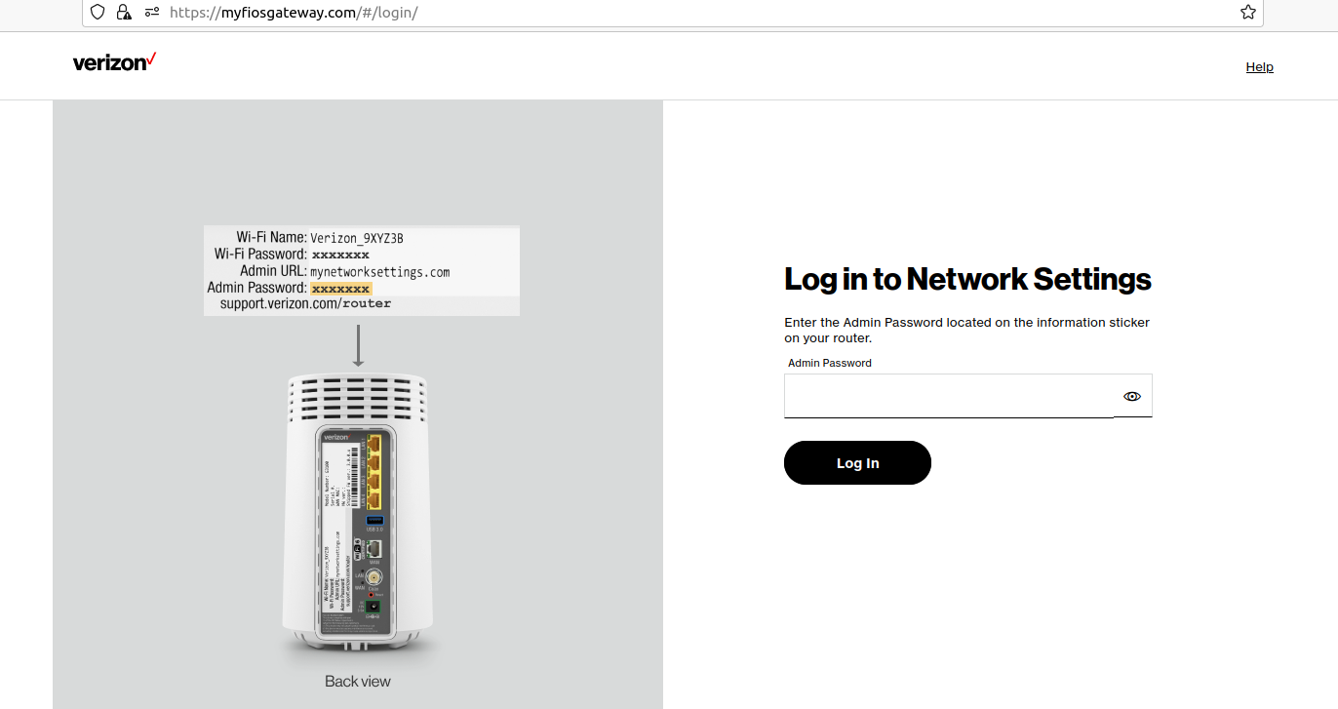

Step 3. Enable Guest Wifi, if you do not already have your router configured to allow a guest network. Take note of the username and password for use when you image your sd card with Raspbian Imager.

Note: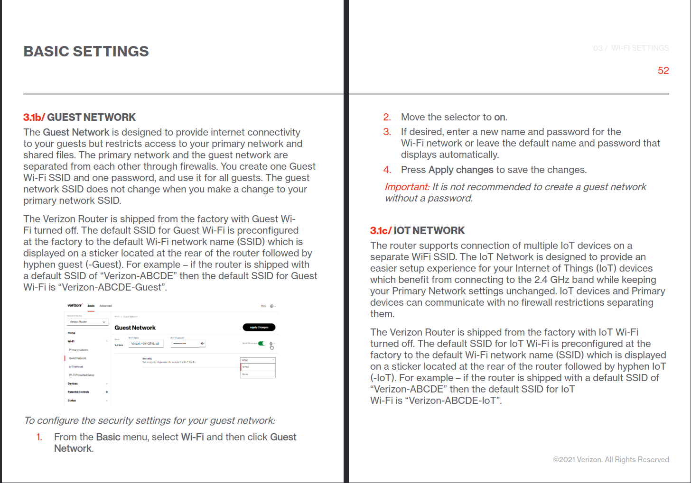 As noted in screenshot above, connecting the dshield honepot through the guest wifi will segregate it from other devices on the primary network wifi with the default Verizon Fios router firewall. The IOT network has no firewall protections between the primary network using default settings.

Step 4. Perform the steps listed in the dshield setup located at <https://isc.sans.edu/honeypotinstall.pdf>

Step 5. Plug-in your raspberry pi power adapter and give it a couple minutes to boot up and join your wifi guest network.

Step 6. Connect to the guest wifi network with the computer you will use to ssh to the rasberry pi to finish the steps listed in the dshield setup guide above. (Note: you could also connect a Ethernet cable to your raspberry pi for setup if you would like however, this would bypass the firewall between the primary and guest networks so it is not recommended to keep it connected once you install the dshield honeypot repo on your raspberry pi.)

Step 7. Once you have fully completed the dshield honeypot setup and restarted the device, login to the Verizon Fios router Admin URL with a device connected to the primary network and expose the IP associated to your honeypot by clicking on the advanced tab, then Security & Firewall, then DMZ Host. Use the drop down for Local Host and select the honepot’s IP on the guest network, it will be different from the primary network IPs. Click on DMZ IPv4 Host toggle button and then apply changes.

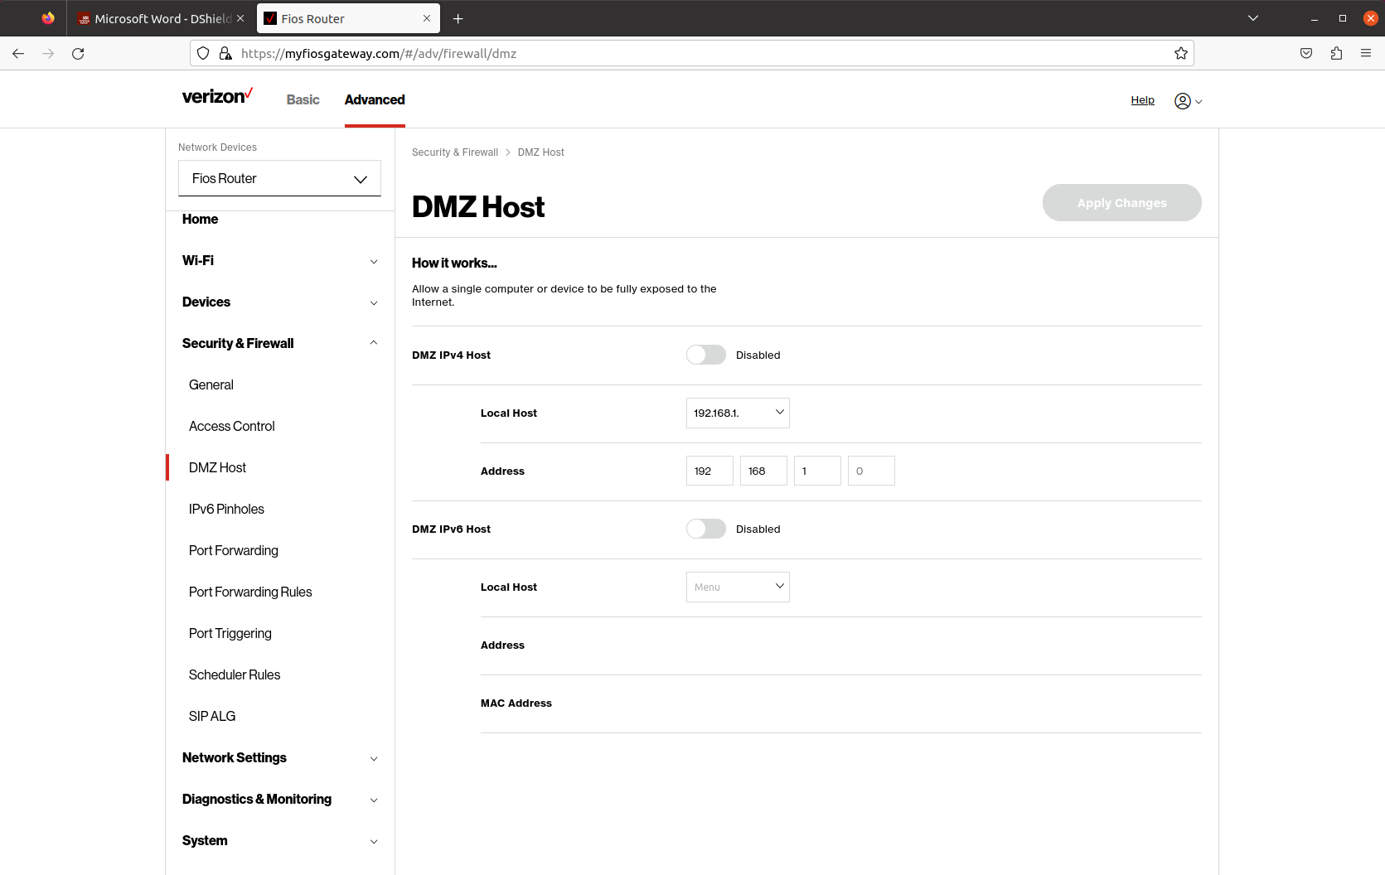

References:

1. Dshield Setup instructions: https://isc.sans.edu/honeypotinstall.pdf

2. Verizon Router User Guide: <https://www.verizon.com/supportresources/content/dam/verizon/support/consumer/documents/internet/verizon-router_user-guide.pdf>